**GOKARNA - THE HEAVEN OF TOURIST**

**ABOUT**

Gokarna is a small temple town on the western coast of India in the Kumta taluk of Uttara Kannada district of the state of Karnataka,India. The main temple and deity is Shiva, who is also known as Mahabaleshwara. This temple houses what is believed to be original image of Shiva's linga (Atmalinga). There are many other temples all over this small town. Ankola and Kumta on NH66 are the main towns where as Bhatkal and Karwar are the main small cities near Gokarna where almost all trains have halts and are connected to major cities like Chennai, Bangalore, Hyderabad, Mangalore and Mumbai through bus service.

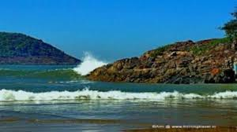

Gokarna is known as one of the seven important Hindu pilgrimage centers. It is on what was once an unspoiled beach near the estuary of the river Aghanashini. Recently, due to the influx of tourists, the character of the town has changed; it is no longer just a centre of pilgrimage, though large numbers of devotees visit to offer prayers and worship to Shiva.

Due to its laid-back, unspoiled and rustic nature many younger western tourists started visiting Gokarna about three decades ago. Enterprising locals started stores and restaurants. Later the onset of millennial youth increased the tourism. Now the resorts also cater to wealthier tourists.

**ETYMOLOGY**

Gokarna means cow's ear. It is believed that Shiva emerged from the ear of a cow (Prithvi, the Mother Earth) here. It is at the ear-shaped confluence of two rivers Gangavali and Aghanashini.

The Bhagavata Purana relates that 200 years into this current kali yuga a pious brahmana named Atmaveda was unable because of karma incurred in past lives to have any children in his current incarnation. Atmaveda was devastated by not being able to have children, and wandered into a forest to pray for help. There he met a Sannyasi, whom he implored to grant him and his wife the ability to have a child. The Sannyasi warned Atmaveda against opposing his karma, but finally relented and gave Atmaveda a fruit that his wife was to consume to have a child. Atmaveda's wife Dhundhuli didn’t want to go through the pain of pregnancy and childbirth, so she gave the fruit from the Sannyasi to her cow. A human child was born of the cow, human in all its parts except for its ears, which were cow ears. Because of this the child was named Gokarna.

Gokarna is mentioned in the Shrimad Bhagavata Purana as being the home of the brothers Gokarna and Dhundhakari. In order that Brahma who out of arrogance arising out of his power to create the universe, sat penancing to redeem himself from curse of Shiva, the latter appeared in front of him from the ears of a cow. So the place came to be known as Gokarna or ear of the cow. Hindu Puranas says that when Parashurama, the sixth avatar of Vishnu created Kerala, it was from Gokarna to Kanyakumari.

As per legend, Ravana was given Atmalinga by Shiva and instructed that it would stay permanently where it is first placed on the land. But Ganesha came in the form of a boy and planted it in Gokarna while Ravana was performing rituals. Once placed Ravana could not remove it from the ground, but he removed some pieces of the Linga and threw them in different directions

**LOCATION**

Gokarna is located near Arabian Sea on the west coast of India, near the city of Karwar. It is set in a lush, green environment (also spelt "Gokarn") in Uttara Kannada (or North Kannada district). Gokarna lies between the Gangavalli and Aganashini rivers. National Highway 66 (NH66), a coastal highway on the Western Ghats (from Kanyakumari to Mumbai), passes close to Gokarna. The town is 56 kilometres (35 mi) from Karwar, 252 kilometres (157 mi) from Mangalore, 145 kilometres (90 mi) from Hubli, and 450 kilometres (280 mi) from Bangalore. The nearest airport is at Panaji, Goa, 155 kilometres (96 mi) away.

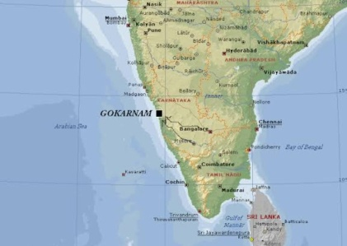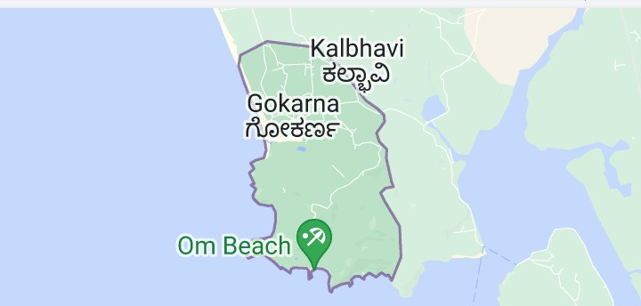

Figure 1 Gokarna Map

**CHAPTER 01:**

**SHREE MAHABALESHWARA TEMPLE**

* 1. **ABOUT**

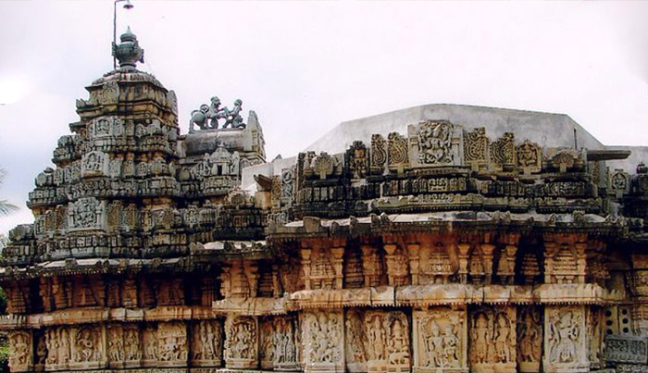

Figure 2: Shree Mahabaleshwar Temple

The Mahabaleshwar Temple, Gokarna is a 4th-century Hindu temple located in Gokarna, Uttara Kannada district, Karnataka state, India which is built in the classical Dravidian architectural style. It is a site of religious pilgrimage. The temple faces the Gokarna beach on the Arabian Sea in which Hindu pilgrims cleanse before visiting the temple for worship. The temple deifies the *Pranalinga* ("the reality of God which can be captured by the mind") also called *Atmalinga* or *Shiva Linga.* In legend, it is said that the deity of the temple will bestow immense blessings to devotees, even to those who only glimpse it. Currently the administrative charge of the temple is with an Overseeing Committee under the Chairmanship of Justice BN Srikrishna, a Retired Justice of the Hon'ble Supreme Court of India.

* 1. **HISTORY**

.

The temple is one of the seven sacred Muktikshetras or Muktistala ("places of salvation") in Karnataka. It is a place where many Hindus of Karnataka perform obsequies (death rites) for their departed. Accordingly, the Atmalinga was perforce placed at Gokarna, in the temple precincts where it is now deified. It was Ravana, the demon King of Lanka, known from the epic, Ravana had carried it there from Mount Kailash in the Himalayas. This is one of the holiest site for shiva and finds its mention in several Puranas, Ramayana and the Mahabharata.

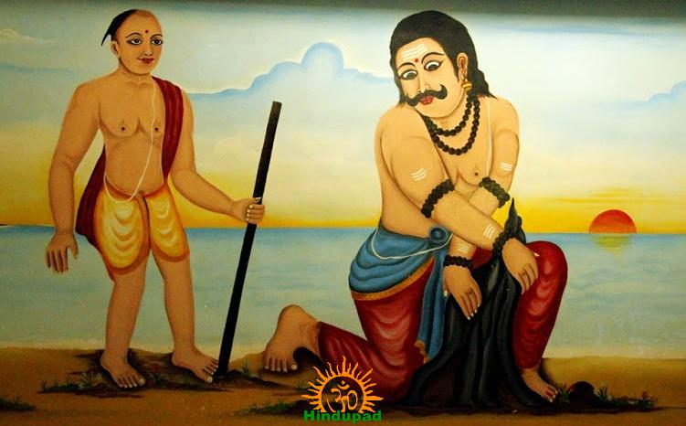

Figure 3 Ravana trying to lift the atma linga

The temple's first construction was by the king Mayurasharma of the Kadamba dynasty (reign 345 CE – 365 CE). Again, legend holds that Mayurasharma wished to learn of the Vedic rites and the Ashwamedha Yagna (ritual of horse sacrifice). He travelled to Kanchipuram, a major religious learning centre, but there, he was insulted by a horseman guard. He was angered and swore to defeat the ruling Pallava dynasty. Following his defeat of the Pallavas, the king asked some priests to perform a daily yajna to maintain his suzerainty over the region. Mayurasharma's son, King Kangavarma brought Brahmin families from different lineages to maintain administration at the temple.

The classical Sanskrit writer, Kalidasa mentions the "Lord of Gokarna" in his 4th century work, Raghuvamsha. The Gokarna temple is recorded as one of the Paadal Petra Sthalams in the 7th century Tevaram by Appar and Sambandar wrote canon of devotional poetry.

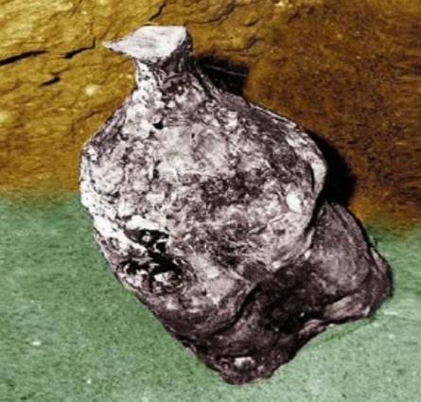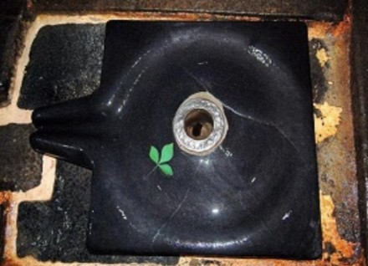

Figure 4 Atmalinga

The temple is a large complex of shrines and much of it belongs to the later Vijayanagara period (1336–1646 CE). A Vijayanagara emperor once visited the temple and weighed himself in gold.

During the 17th century reign of Queen Chennammaji and her son, Soma Sekharanayaka of Keladi, Visvesvaraya of Halasunadu-Kundapura built the Chandrasala and Nandi pavilions. In 1665, the warrior king, Shivaji (1630 CE - 1680 CE) worshipped at the Mahabaleshwar temple after disbanding his army in Gokarna.

**1.3 RELIGIOUS PRACTICES**

The religious practices observed by most devotees, who are accompanied by their priests, consist of shaving their head, fasting and then taking a bath in the Arabian Sea, opposite the temple. They then pay obeisance to Lord Ganesha (the elephant headed god) deified in the Shri Maha Ganapathi temple, which is a few yards away from the Mahabaleshwar temple. After observing these religious procedures, devotees visit the main shrine of Mahabaleshwar for the Darśana (the auspicious sight of a deity). The idol is placed inside a pit on the floor. The devotees can touch the idol and do the puja by themselves. This is in contrary to other temples where the devotees are neither allowed to touch the idol nor do puja.

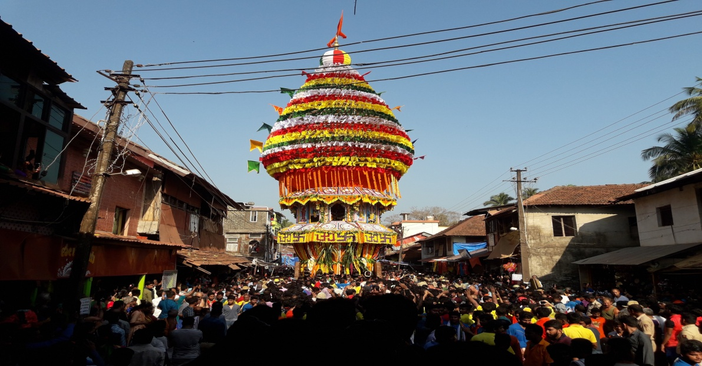

Figure 5 Ratha Yatra during Shiratri

The Shivaratri festival, the observance of the union of Lord Shiva and Goddess Parvati is celebrated in Gokarna on the 14th day of the dark fortnight in the month of Magha, coming either in February or March, when a very large number of pilgrims visit the shrine. During the festival, a Rath Yatra (a procession in a large wooden chariot) is held. Images of Shiva and other deities are installed in a chariot which is ceremoniously pulled through the town by the devotees, accompanied by drum bands. The Ratha Yatra starts from the Shri Maha Ganapati temple at the terminus of the main market street, also known as "Car Street".

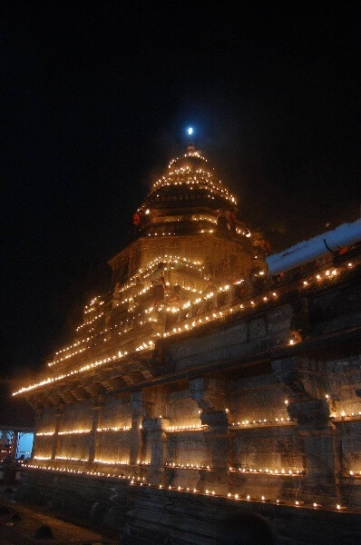 During time of Kartika Maasa 1 lakh diya were lighed all around the temple. It was known as thripurakhya Derpotsava. Some other festivals too take place in a grand way. Kotiteertha, Arabian Sea near to the temple, gayatri teertha are some important places where the events related to temple takes place. Kotitheertha is a man-made pond, which is used for the immersion of idols and ritual bathing. It is surrounded by temples and has small platform in the centre. Devotees usually take bath in the pond before they visit the Mahabaleshwar Temple for worship.

Figure 6 Tripurakhya Deepotsava

**CHAPTER 02:**

**SHIVA CAVE**

Shiva Cave is a fascinating place to visit on your visit to Gokarna that is not much popular among tourists yet. Consisting of a Shiva Lingam, Shiva Cave is an interesting place that people should visit.

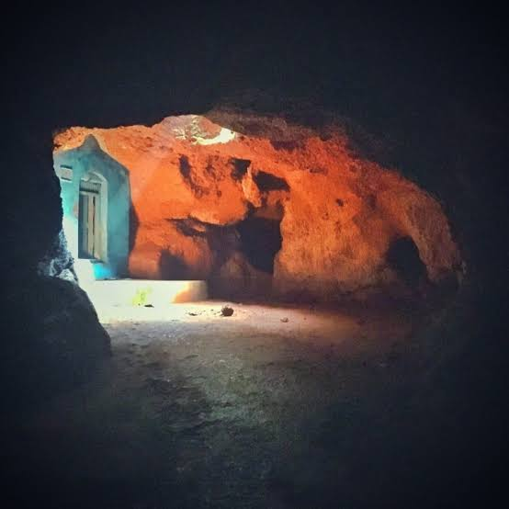

Figure 7 Shiva Cave

With its dark interiors which gives a mysterious feel , tourists are advised to carry a torch inside when they are visiting here. It is also home to many bats and has an interesting legend associated with it. With its beautiful surroundings, Shiva Cave is an amazing place to visit for everyone. Inside the cave there is a Shiva Temple where devotees come to seek fulfilment of their wishes.

**Location:** Gokarna-Kudle Road, Gokarna, Karnataka

**Best Time to visit**: November to February is the best time to visit Shiva Cave in Gokarna

**Distance from Gokarna Bus Main Stand, Banglegudda:** It is approximately 5.5 kilometres away from the Gokarna Bus Stand.

**CHAPTER 03:**

**BEACHES**

**3.1 OM BEACH**

**3.1.a ABOUT**

Om Beach is a major tourist attraction in the coastal city of Gokarna, located in North Canara district. One of the acclaimed beaches in the country, Om Beach takes the shape of an ‘Om’, a Hindu spiritual symbol. In the shape of two crescents joined together to form an Om, the beach offers a breathtaking view of the sunset. The long stretch of white sandy beach adjoining the rocky terrain appeals to travellers from around the world.

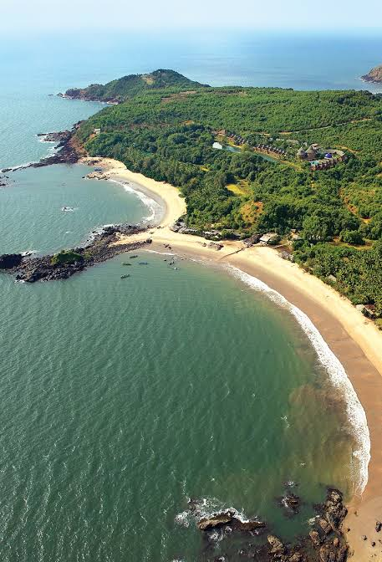

Figure 8 Om Beach

**3.1.b How to reach Om Beach,Gokarna**:

Om beach is 6 kms from Gokarna city centre. Gokarna is 500 kms from Bengaluru and 230 kms from Mangaluru. Goa is the nearest airport (150 kms from Gokarna). Ankola is the nearest railway station (19 kms). From Gokarna city, auto or taxi can be hired to reach Om Beach.

**3.1.c Activities to try at Om Beach**

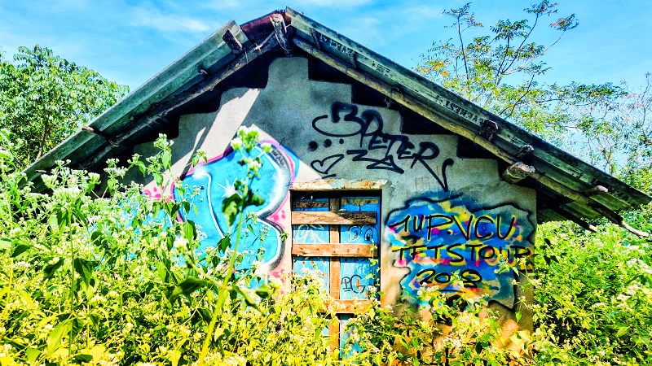

Figure 9 Art by Tourists on a old wall

* **Sunset watching:** Sunset in the Arabian Sea is always spectacular to watch. Gokarna’s Om beach offers excellent sunset views.
* **Water sports:** Jet Ski ride, banana boat rides, parasailing and surfing are some of the activities to try in Gokarna’s Om beach. Activities are offered by private operators and not all activities may be available at all times.
* **Hiking:** Hills around Gokarna offer good hiking opportunities. Hike to Om Beach viewpoint, Om Beach Rock View and Rock of Peace near Om Beach for a great view of the beach and ocean.

**3.2 KUDLE BEACH**

**3.2.a ABOUT:**

Kudle Beach in Gokarna is renowned for its unmatched beauty and mesmerizing charm. Flanked by tall coconut trees, this piece of land resembles a perfect ‘C'. Representing a vastly stretched piece of an isolated sea and land, Kudle Beach is the best option to try for those who seek solitude. With serene and quiet atmosphere, watching the sunrise and sunsets are the real delights for the observers. You can either sit on the shore or gaze at the never-ceasing tides – the choice is yours!

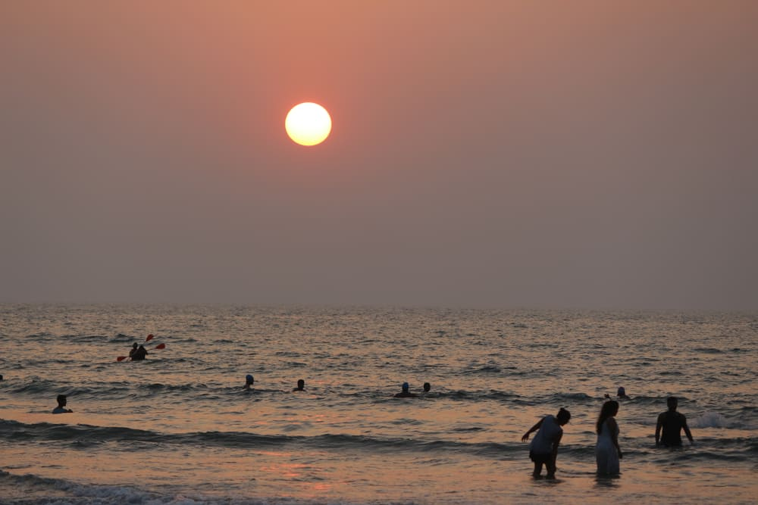

Figure 10 Kudle Beach

Locals visit here for early morning or late evening walks and their yoga sessions. You can also join them. Stroll around for some time, and you are surely going to find some beautiful beach shacks and bamboo huts to plan your night camping. This is the perfect moment to shoot the beauty of glistening waters under the dim light of the moon.

**3.2.b BEST TIME TO VISIT**

**Summer:** The period between April to June marks summers in Gokarna. With the temperature rising up to 40 degrees, you can expect a hot and humid climate. This makes most travelers to avoid summers for their Kudle Beach holiday.

**Winters:** November to March is the winter season here in Gokarna and the best time to plan your visit. With a temperature falling between 20 to 30 degrees, this season is most preferred to enjoy the sunbathing activity at Kudle Beach. Also, if you are fond of and get a chance to try the seafood here, don’t resist your stomach cravings. It's simply delicious!

**3.2.c Water Sports at Kudle Beach:**

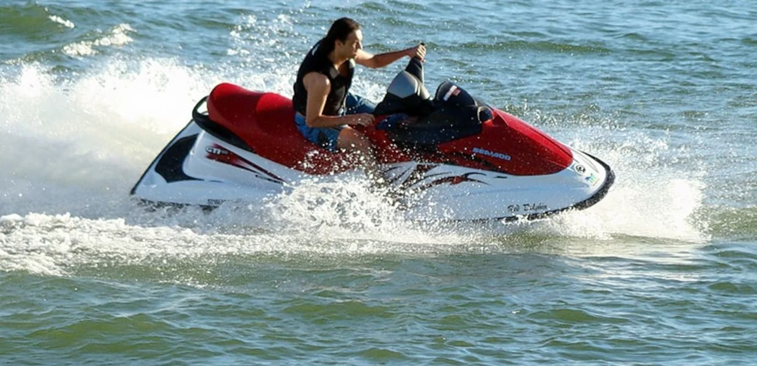

Figure 11 Water Sports

* **Kayaking:**Kayaking activity helps you to move across the tides of water. This water activity at Kudle Beach is continuously gaining popularity, specifically amongst the youth visiting here.
* **Jet Skiing:** This motorsport or personal watercraft adventure is executed under an efficiently trained Jet Ski instructor.
* **Banana Boat:** Banana Boat is a yellow banana shaped hot air balloon for adult entertainment. Your kids won’t be allowed to accompany you on this ride. Also, banana boat riders are given life-jackets to enjoy the activity safely.

**3.3 PATANGA BEACH**

**ABOUT**

Situated 12km from Gokarna Railway Station, Patang Resort is a beach resort offering 24-hourfront desk facility and room service.This Gokarnaresort accommodates 17 well-furnished huts equipped with bottled/drinkingwater, wardrobe and an attached bathroom with hot and cold water facility.Activitieslike bird watching, fishing and water sports are arranged by the resort. Thein-house restaurant serves mouth-watering Chinese, Mexican, Continental andItalian foods..Patang Resortis 160 km from the airport. Kudle Beach- 9 km, Om Beach- 65 km, MahabaleshwaraTemple- 10 km, Mirjan Fort- 25 km and Kotiteertha- 20 km are the famous nearbyattractions from this property.

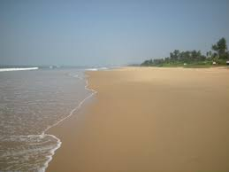

Figure 12 Patanga Beach

**3.4 GOKARNA BEACH**

**ABOUT**

The Main Beach or the **Gokarna Beach** is famous amongst the pilgrims because of its closeness to the famous Mahabaleshwar Temple. It is believed that only after a dip in the beach one can enter the holy temple worshiping Lord Shiva. This beach is comparatively a crowded beach but an early morning walk along the same leaves you spell-bound.

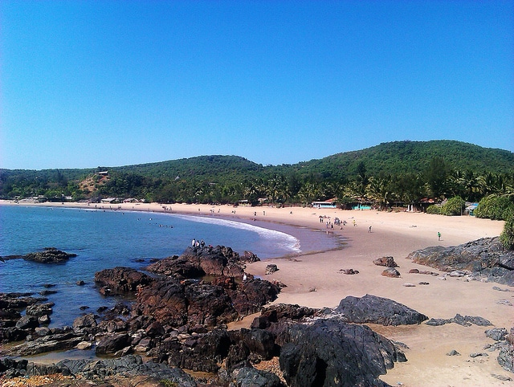

Figure 13 Main Beach

This beach gives off some of the most beautiful sights of the ocean and the surrounding hillocks. Some of the adventure activities you can engage in Gokarna Beach include surfing, jet skiing, snorkeling as well as trekking.   
**Location:**Gorkana Village | Ankola, Gokarna, India  
**Best Time to visit:**October to March.**Activities and Watersports:** Yoga, surfing, jet ski, banana boat, snorkeling, and trekking.

**Distance from Gokarna Bus Main Stand:** Around a KM away.

**CHAPTER 04:**

**WHITE PEARL CRUISE**

It has been the dream of Coastline Ventures to create a world-class experience at Gokarna for exploring & enchanting the Estuaries, Arabian sea & Western ghats especially in the state of Karnataka where they are still pristine and less touched. This will be home for the first cruise experience on one of the last remaining free-flowing water body. The Aghnashini creates an extensive and biodiverse estuary habitat before meandering into the Arabian sea at the confluence point. The Estuary is a massive water body (2000 hectares), providing livelihood to thousands of fisher flock and farmers along its banks. Endowed with hundreds of hectares of mangroves, the estuarine ecosystem is home to extraordinary flora and fauna.

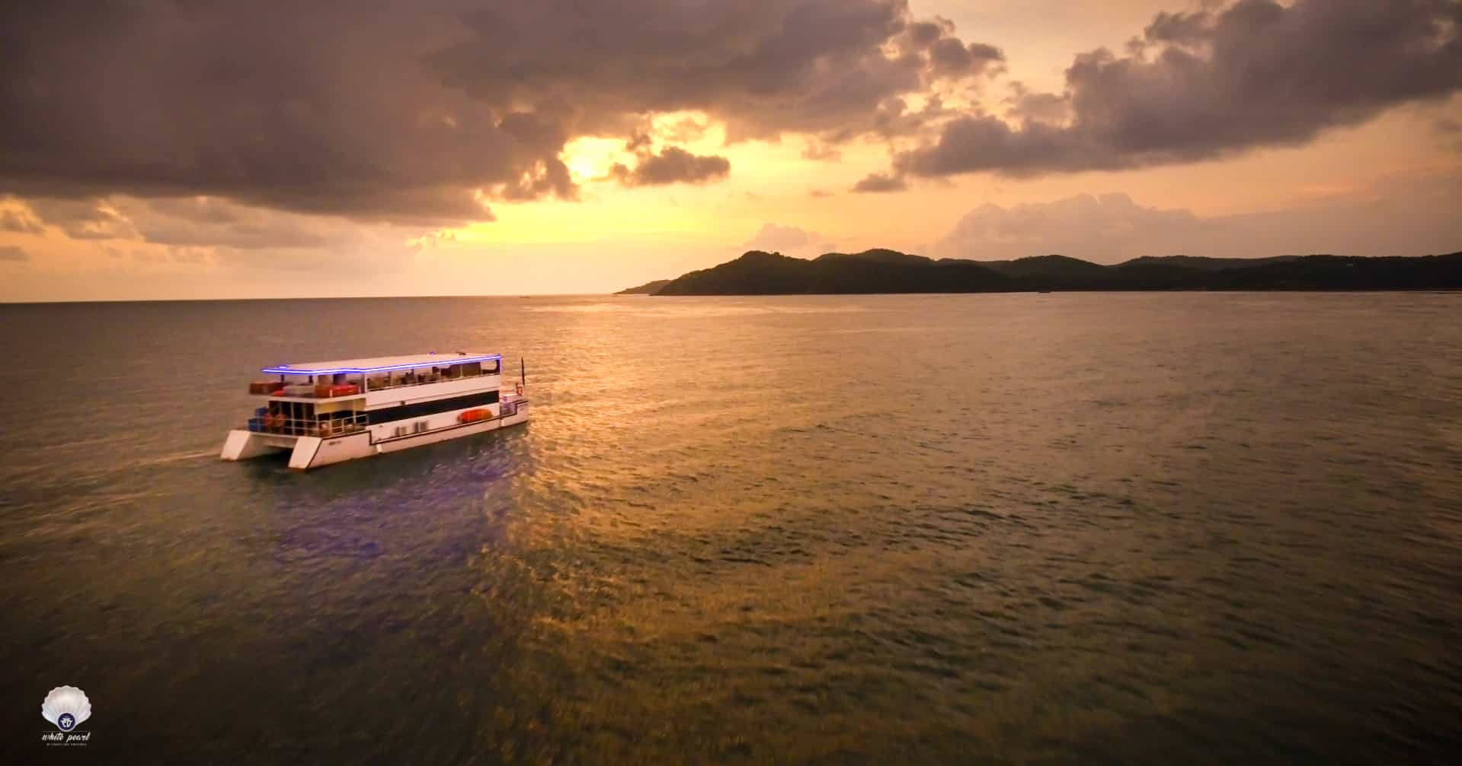

Figure 14 Cruise

**CHAPER 05:**

**SWASWARA**

A world where luxury is time to yourself - time to think, time to let go, time to heal. Welcome to SwaSwara, located on Om beach, Gokarna in Karnataka. Here, 26 acres of greenery and 24 villas inspired by the homesteads, tradition and craft of coastal Kannada region of Karnataka will open up for you the simple joys of life like never before. A holiday that is not about losing yourself, but finding your self - one that is not an escape, but an introduction. At SwaSwara, the noises of the modern world give way to the whispers of the sea. All that breaks the silence is the rhythm of rolling waves, the meditative hum of the birdsong and at times, the chiming of the temple bells of Gokarna faraway. A resounding quietude that makes you aware of the inner sound of your being, drowned out as it is by the din of daily life. Here, under the guidance of a team of well-trained doctors, yoga instructors and therapists you'll discover yourself through Yoga, Pranayama, Ayurveda, naturopathy, meditation, healthy eating, interactive cooking, guided art sessions and communing with nature - experiences that will invoke your ‘SwaSwara’, the music of your soul.

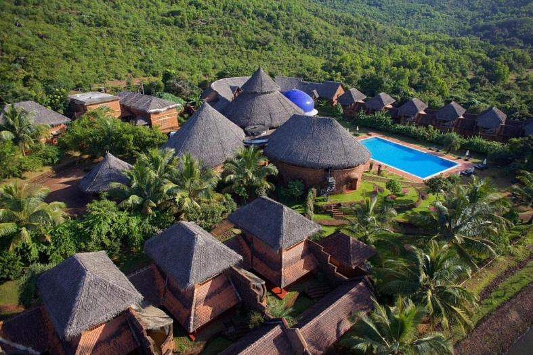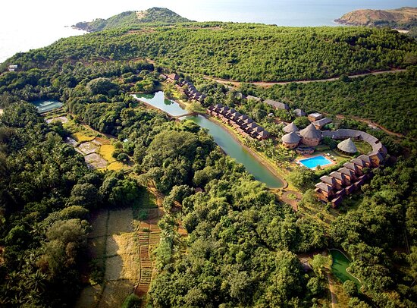

Figure 15 Swaswara

* Experience of Swaswara is not meant for kids below 12 years of age and hence they are not encouraged
* Stay packages consist of minimum five to seven days
* Located 12 kms from Gokarna

**CHAPTER 06:**

**COLOURFULL RESORTS**

Gokarna is a small town engulfed with the vast ocean around it. It is a town that is acknowledged for its beautiful landscapes, adventure activities and some water sports to enjoy. Gokarna is a scenic town that is home to many beautiful beaches and ancient temples. Adding to the beauty of this place is the wide variety of resorts, that not only boast of great amenities, food and other comforts but also cater to all types of tourists. Here are some of the most beautiful resorts in Gokarna for all budget types!

**6. 1 KAHANI PARADISE**

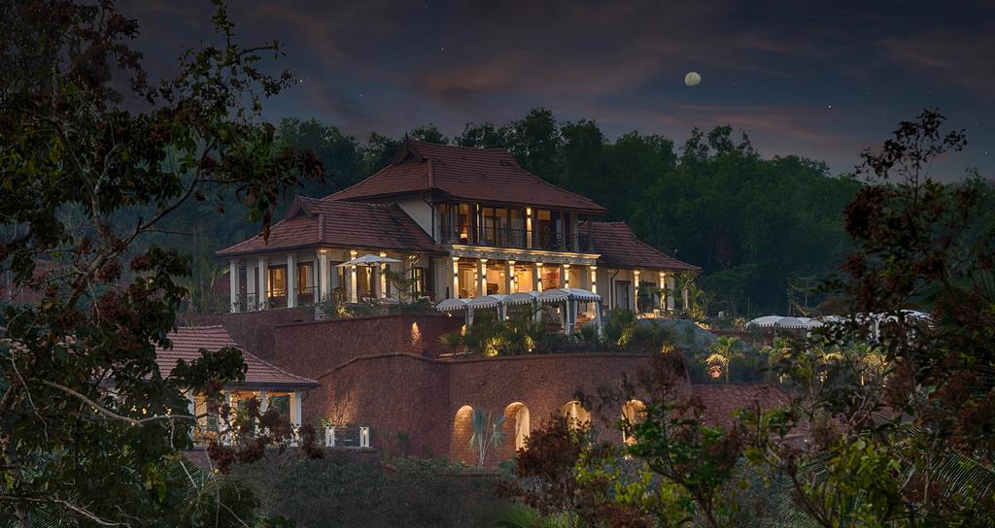

Figure 16 Kahani resort

Kahani Paradise is one of the most stunning accommodations in Gokarna. Kahani Paradise sits on a 20-acre estate of garden, forest and farm. They have a motto of ‘A kingdom to call your own’ and this beautiful and comfortable stay will make you feel like home. This resort will definitely surpass your expectations. The rooms and hotel are stunningly beautiful and decorated with exquisite taste. The swimming pool is a real gem and the dining area is majestic. From here you can take a 360-degree view of the scenic beauty and also enjoy a wide array of world-class amenities. Whether you wish to stay at the well-appointed villa or the deluxe rooms, here you can pick your selection.

**Cost**: Rs 19,000 onwards

**6.2 KUDLE BEACH RESORT AND SPA**

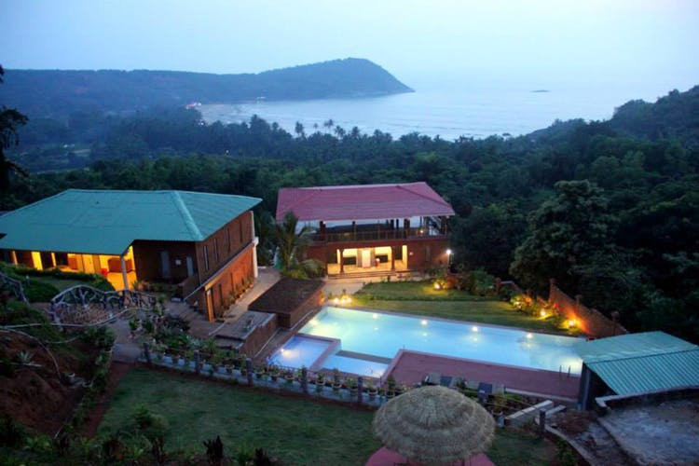 Kudle is one of the best resorts in Gokarna for the those who live life with a simplistic approach. The property is located at Kudle beach, 2 Kms from Gokarna temple, and 130 Kms from Panaji, Goa. The resort not only offer a comfortable stay, but also a myriad of activities such as sightseeing, Yoga, scuba, and other water activities. The amenities of the resort include 24 hours assistance, an outdoor pool, multi-cuisine restaurant, help desk, children friendly, hot and cold running water, internet access, and free parking.

Figure 17 kudle beach spa and resort

**Cost**: Rs 6,000 onwards

**6.3 SANSKRUTI RESORT**

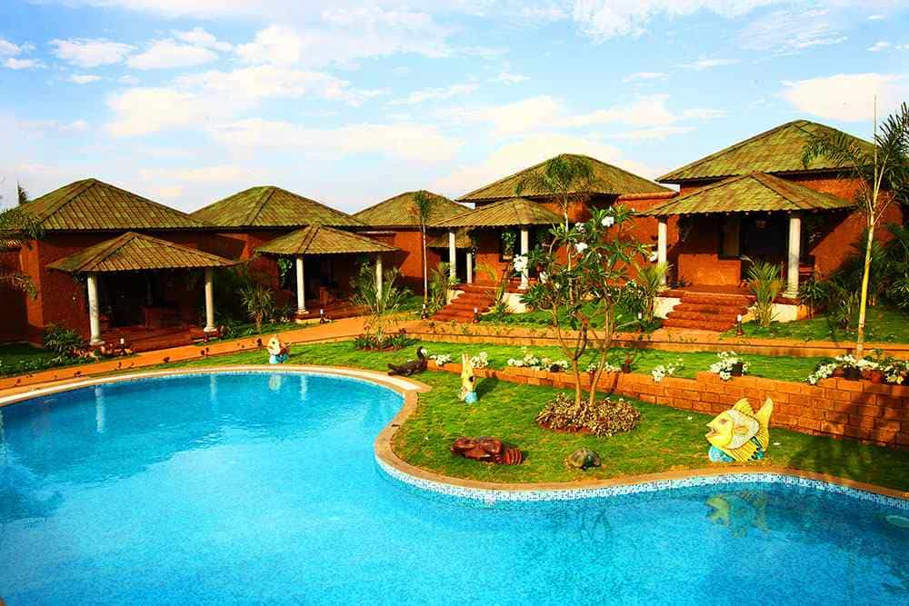Offering 4-star quality amenities to its guests, the Sanskruti Resort is one of the best Gokarna resorts. Consisting of 10 valley view rooms and 20 luxurious cottages, this resort is one of the classiest and most elegant places to stay in town. Also, this property boasts of not just one, but two swimming pools. Other facilities include A/C restaurant, gymnasium, conference hall, and a garden.

Figure 18 sanskruti resort

**Cost**: Rs 6,000 onwards

## **CHAPTER: 07**

## **CITY SHOPPING**

**ABOUT**

## Shopping for the local specialties and taking back souvenirs is definitely among the top most things-to-do when one goes on a holiday. A trip to Gokarna is no different. Having been through the various pilgrimage sites and the mesmerizing beaches, one won't be able to stop himself/herself from splurging a bit on shopping after having a look at the local markets. Shopping in Gokarna is an absolute delight, and one can get amazing stuff at rock bottom prices if they're well-versed in the art of bargaining.

Shopping in Gokarna is all about buying souvenirs like brass lamps, prayer beads, picture frames of Gods and Goddesses, incense sticks and other religious items. Other than this, you can also pick up some decorative items or jewelry made from seashells. Most of the street stalls sell these items.  
  
Kallusakkare, a kind of sugar candy with a refreshing taste is a specialty of Gokarna, and a must try. One can find several small shops lined up on the main streets of Gokarna attracting the tourists with their brightly colored merchandise. You will also find some shops selling interesting curios which make for an excellent souvenir.

